TANF Sample Cases Review Guide

For the Federal Report



*Economic and Employment Services*  ES-4305 05/10/2024

# 

# Basic Overview of TANF Report Sample Case Review

Federal requirements mandate all states meet work participation standards. The Kansas Department for Children and Families (DCF), complies with such requirements by performing **Sample Case Reviews.**

Each month, random sample cases are selected from cases in the previous month. Kansas is required to sample no less than three thousand open TANF cases a year. Each month approximately fifty new cases, fifty 2P cases, one hundred fifty 1P cases and roughly sixty-five 0P cases are selected. The report is available the first day of the month following the sample month.

The benefits of the sample case review are as follows:

• Provide on-the-spot training for career navigators.

• Determine training needs for the regions.

• Help clarify policy and procedures.

This guide is designed to help the regions report and document client participation with TANF Employment Services. Every case that is pulled in a sample case review will have a 2nd party review completed by the Management Evaluation Unit.

**Basic Procedure of TANF Report Sample Case Review**

The career navigator is responsible for the following on each TANF Employment Services case:

1. Setting the client up in appropriate activities.
2. Determine the required hours of client participation for each activity.
3. Ensure appropriate documentation of participation hours for each activity can be found in the case file.

4. Make sure information in the case file is factual, neutral, and does not reflect personal opinions about the client being served.

The career navigator is responsible for the following on each TANF Sample case:

1. Complete the ES-4304 for all 1P and 2P Households.
2. Complete the ES-4304 for 0P cases only if the parent is meeting the federal participation requirement.
3. Attach verification of all countable hours to the ES-4304.
4. Scan all ES-4304’s into Perceptive Content by the 10th of the month.
5. Enter appropriate hours of participation for each countable activity on the Activity Progress Detail page.
6. Investigate the case for additional activities if the case does not meet the federal participation rate.

The Management Evaluation unit is responsible for the following on each TANF Sample case:

1. Review each case to determine if activities are appropriate for the sample month.
2. Review the hours of participation listed on the Activity Progress Detail page for accuracy in the sample month.
3. Determine if appropriate verification of hours for the sample month is attached to the ES-4304.
4. Complete a CARE review for each case read.
5. Maintain records for 3 years.

DCF Administration personnel may review the sample cases and provide feedback. All corrections requested by DCF Administration must be completed and sent back within 10 days.

The review deadlines help meet DCF quarterly deadlines. DCF Processing Deadlines can be found on the DCF Intranet under Policy and Procedures.

Any questions should be sent to:

the TANF Program Specialist

DCF.ESPolicyQuestions@ks.gov

The final report is sent to Health and Human Services approximately five weeks after the end of each quarter. October, November, and December months will be submitted in February. January, February, and March are submitted in May. April, May, and June will be submitted in August. July, August, and September will be submitted in November. Exact dates for the DCF Processing Deadlines can be found on the DCF Intranet under Policy and Procedures.

**Note:** *It is very important that all corrections and changes are made prior to the yearend Federal report. The deadline to submit changes for the federal fiscal year (October 1 through September 30), is December 31.*

**Table of Contents**

Basic Overview of TANF Report Sample Case Review 2

Steps in KEES 6

Case Summary page 6

Examples of a 2P HH based on Relationship- 7

WP Status List page 8

Test Scores List Page 9

Medical Condition List page 10

Customer Activities List page 12

Activity Progress Detail page 12

What to include on the Checklist 16

*How the Actual, Projection and Average hours are calculated* 16

*Other verifications used to calculate reported hours* 18

*Who verified the hours, if a collateral contact was made* 18

*Academic statement providing standard for study hours and hours in class* 18

Primary Activities 18

*1. Unsubsidized Employment* 18

*2. Subsidized Public Employment* 18

*3. Subsidized Private Employment* 19

*4. Work Experience* 19

*5. On-the-Job Training* 19

*6. Vocational Education* 19

*7. Job Search/Job Readiness* 20

What WP activity to use when a client becomes enrolled in an ESL class: 20

What WP activity to use when a client becomes enlisted in the military: 20

Calculating Hours for Employment 21

*Calculating Hours of Employment in a Full Month* 21

*Calculating Hours of Employment in an Application Month* 22

*Calculating Hours of Employment in a Partial Month* 24

*Calculating Hours for Day Labor* 25

*Calculating Hours for Self-Employment* 26

*Calculating Hours for Work Experience* 27

*Calculating Hours for Vocational Education* 28

*Calculating Hours for Job Search/Job Readiness* 30

Secondary Activities 31

*1. Job Skills Training* 31

*2. Education Directly Related to Employment* 32

*3. Satisfactory Attendance at Secondary School or in a GED Program* 32

Parents Not in Work Programs 32

Other Tips: 33

Helpful Hints if Federal Participation is Not Met 33

Things to Remember Before Checking the Work Number: 34

Minimum Hours of Participation to meet the Federal Participation Rate 36

Q&A 36

# Steps in KEES

Review KEES data for all adults and minor parents on the TANF case. KEES uses the data collection pages to identify 2P, 1P and 0P families as well as work eligible individuals for the TANF report, therefore, it is important KEES data is accurate. The following information must be reviewed and corrected for the sample month before the Preliminary TANF report is run.

## Case Summary page

* Assure all mandatory adults and minor parents with a role of MEM on the TANF block are active on the Work Programs block.
* Assure all adults and minor parents with a role of FRE on the TANF block are active on the Work Program block if they are Work Eligible Individuals.
* Assure all parents with a role of FRE on the TANF block are active on the Work Program block if they are exempt from work programs but are meeting participation.
* If a person is an SSI recipient and a member of the MFU (Mandatory Filing Unit), verify the TANF role is UP. A work program block should only be opened if the person is a parent meeting participation.

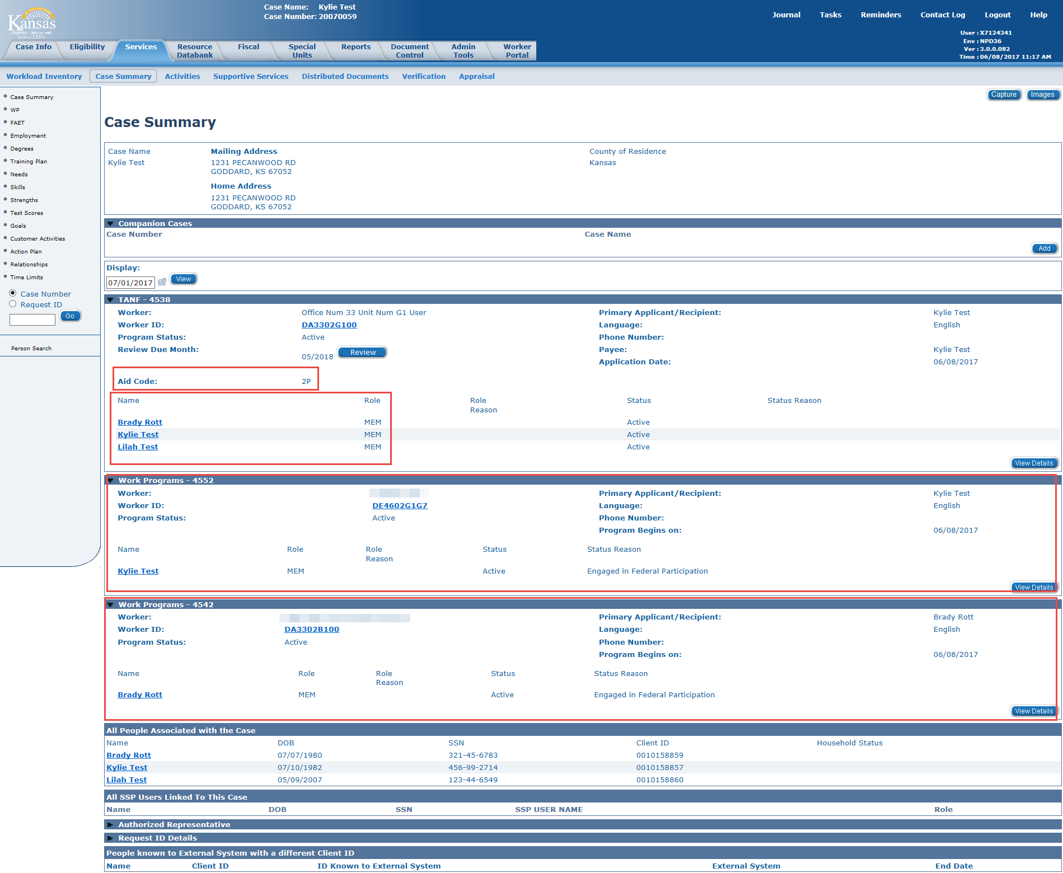

### **Examples of a 2P HH based on Relationship**-

allowing that both adults are work eligible individuals with a role of MEM for TANF.

1. Parent - Spouse – Mutual Child                                  2P HH

(both adults have a relationship of parent to the child)

1. Parent – Spouse – Non-Mutual Child                       1P HH

(Spouse has a relationship of stepparent to the child)

1. Minor Parent – Spouse – Mutual Child                    2P HH

(minor parent is emancipated through marriage-emancipation date must be completed or the minor parent is the case head)

1. Minor Parent – Boyfriend – Mutual Child               1P HH

(both adults have a relationship of parent to the child, but Minor Parent not emancipated)

1. Parent – Boyfriend - Mutual Child                             2P HH

(both adults have a relationship of parent to the child)

1. Parent – Boyfriend – Non-Mutual Child                  1P HH

(boyfriend is unrelated to parent & child)

1. Pregnant Woman – Spouse – Unborn                      1P HH

(Even though he is spouse, there is no child on the TANF case to show relationship to spouse. This will change after the newborn is added to the HH)

1. Pregnant Woman – Boyfriend – Unborn                 1P HH

(Boyfriend is unrelated to the Pregnant Woman if there is no child to show relationship)

This Relationship List page shows Mary as the Parent of Baby and Unrelated to John. John also shows as Parent of Baby making this a 2 Parent household.

**Relationship List**

|  |  |  |  |  |  |  |  |  |
| --- | --- | --- | --- | --- | --- | --- | --- | --- |
|  |  | **Person 1** | **Relationship** | **Person 2** | **Parental Control** | **Begin Date** | **End Date** | **Action** |
|  |  | **[sort Descending](javascript:setOrderBy(%20'PERS_NAME',%20'DESC'%20))** | **[sort Ascending](javascript:setOrderBy(%20'TYPE_CODE',%20'ASC'%20))** | **[sort Ascending](javascript:setOrderBy(%20'PERS_2_NAME',%20'ASC'%20))** |  |  |  |  |
|  |  | **SMITH, JOHN** | **Parent** | **SMITH, BABY** | **No** | **01/22/2020** |  | **[Edit](javascript:cancelForm(%20document.RelationshipList,%20'/datacollection/Relationship/edit?id=18222737&caseId=1003096454'))** |
|  |  | **JONES, MARY** | **Unrelated** | **SMITH, JOHN** | **No** | **02/01/2017** | **06/30/2019** | **[Edit](javascript:cancelForm(%20document.RelationshipList,%20'/datacollection/Relationship/edit?id=14414890&caseId=1003096454'))** |
|  |  |  | **Parent** | **SMITH, BABY** | **No** | **01/22/2020** |  | **[Edit](javascript:cancelForm(%20document.RelationshipList,%20'/datacollection/Relationship/edit?id=18205544&caseId=1003096454'))** |
|  |  |  | **Unrelated** | **SMITH, JOHN** | **No** | **08/01/2016** | **01/31/2017** | **[Edit](javascript:cancelForm(%20document.RelationshipList,%20'/datacollection/Relationship/edit?id=14414889&caseId=1003096454'))** |
|  |  |  | **Unrelated** | **SMITH, JOHN** | **No** | **07/01/2019** |  | **[Edit](javascript:cancelForm(%20document.RelationshipList,%20'/datacollection/Relationship/edit?id=18052059&caseId=1003096454'))** |
|  |  |  |  |  |  |  |  |  |

## WP Status List page

* Assure the WP Registration Status of Mandatory or Exempt is correct for each adult and minor parent on the Work Programs block.

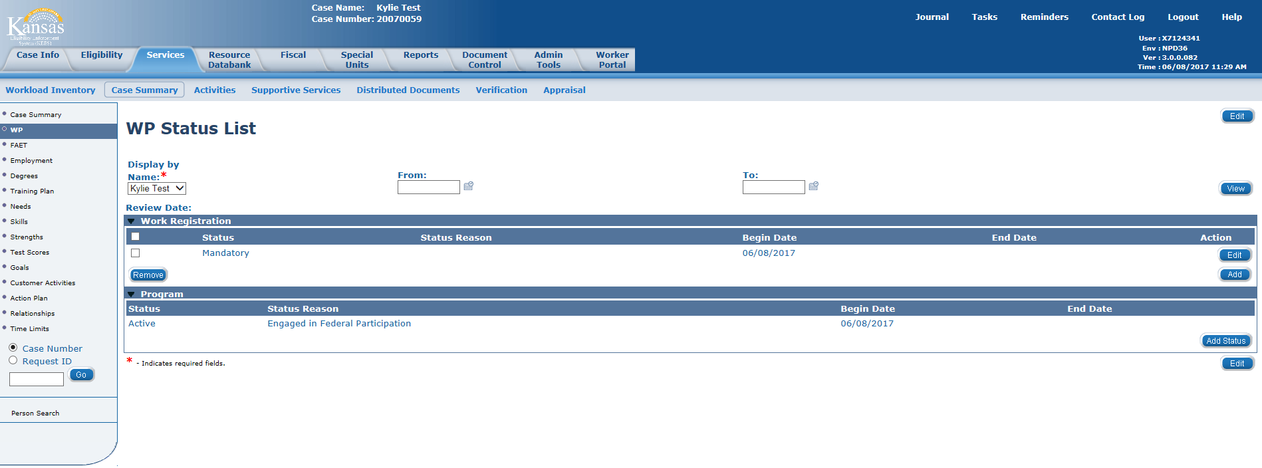

* If a client is Mandatory but has medical documentation stating they are not able to participate in WP activities at this time or if the client is working with Vocational Rehabilitation Services, the career navigator should notify eligibility to update the Medical Condition on the Medical Condition List page. This should only be done if the adult is a parent in a two-parent household. Extended time in the Disability Employment Services activity or the Physical Health Care activity should have substantiating documentation scanned to Perceptive Content, so it is available if the case is pulled for a sample.
* If a client is Exempt but chooses to volunteer, their Work Registration Status should remain Exempt and their Program Status should be Active with the Status Reason as Engaged in Non-Federal Participation. Clients receiving SSI cannot be considered volunteers because they are not eligible for ES services. (see E-1 in the KEESM Appendix).
* If a client would be Exempt because they are needed to care for a disabled HH member but during the assessment it is determined that they are required to participate with SRCC, the Work Program block would remain open, and the client would be required to participate in the Alcohol and Other Drug Treatment and Assessment activity. Once SRCC has determined there is a substance abuse problem, the client is required to participate in their program. Failure to participate in the required substance abuse treatment is an eligibility issue not a WP issue. If the client fails to participate in the substance abuse treatment, they are disqualified for TANF.
* If a client has a Registration Status of Exempt, assure that the correct exclusion reason is listed and there is documentation supporting the reason in the case file. Exclusion Reasons are:
  + One Parent HH-KEES rules will determine a single parent exempt in the month a child is born and the 2 consecutive months following the month of birth. This does not include teen parents or clients with an active Alcohol and Other Drug Assessment and Treatment activity.
  + Caring for Disabled HH Member-must have medical documentation in the file.
  + Ill/Injured/Incapacitated-client has been approved for disability
  + Tribal Work Program-only available in BR County.



## Test Scores List Page

All tests, screenings, and evaluations should be listed on the Test Scores List page.



## Medical Condition List page

The Medical Condition List page should be checked for accuracy on **ALL** 2P TANF samples. When a 2P TANF case is pulled for a sample and we have medical documentation that one of the parents has a medical condition that prevents them from participating in all work program activities, that 2P case can be exempted from the 2P Participation Rate. It is not necessary to check the Medical Condition List page for a 1P HH or a 0P HH.

If a parent has an ‘Active’ medical condition listed on the Medical Condition List page, the career navigator should check:

1. Is the Begin Date in the sample month or prior to it?
2. Is the End Date blank or after the sample month?
3. Do we have medical documentation that the parent has a medical condition that prevents him/her from participating in all work program activities?

If the answer is Yes to all 3 questions, no further action is required. This case will not count against us for the 2P Participation Rate.

If the answer to #1 is No and #3 is Yes and the Medical Condition Type is ‘Incapacity-Verifiable and at Least 30 Days’ or ‘Other Food Assistance Disability’, the career navigator should send a request to Eligibility with the following instructions:

1. Please change the Begin Date for ‘*Client’s Name’* Active medical condition to *‘First Day of the Sample Month’*.
2. Please rerun EDBC for the sample month through the current come up month.
3. Please use the Contact Log to communicate to KDHE that the Begin Date for ‘*Client’s Name’* Active medical condition has been changed for the client.

If the answer to #2 is No and #3 is Yes and the Medical Condition Type is ‘Incapacity-Verifiable and at Least 30 Days’ or ‘Other Food Assistance Disability’, the career navigator should send a request to Eligibility with the following instructions:

1. Please add an ‘Active’ medical condition for *‘Client’s Name’* with the Type of ‘Incapacity-Verifiable and at Least 30 Days’. This condition is expected to last *‘refer to the medical statement’* and should have a Begin Date of *‘date the medical statement was signed by the doctor’*.
2. Please rerun EDBC for the sample month through the current come up month.
3. Please use the Contact Log to communicate to KDHE that an Active verified Medical Condition has been added for *‘Client’s Name’* with a Begin Date of ‘*date the medical statement was signed by the doctor’*.

If the answer to #1 and #2 is yes but the answer to #3 is No and the Medical Condition Type is ‘Incapacity-Verifiable and at Least 30 Days’ or ‘Other Food Assistance Disability’, the career navigator should send a request to Eligibility with the following instructions:

1. Please add an End Date of ‘*the last day of the month prior to the sample month*‘ for the ‘Active’ medical condition for *‘Client’s Name’*.
2. Please rerun EDBC for the sample month through the current come up month.
3. Please use the Contact Log to communicate to KDHE that an Active verified Medical Condition has been ended for *‘Client’s Name’* as of ‘*the last day of the month prior to the sample month* ‘

**NOTE:** Do not request a change if the Medical Condition Type is anything other than ‘Incapacity-Verifiable and at Least 30 Days’ or ‘Other Food Assistance Disability’. If the Medical Condition Type is not ‘Incapacity-Verifiable and at Least 30 Days’ or ‘Other Food Assistance Disability’, that medical condition would remain the same and the career navigator should send a request to add a new medical condition if the answer to #3 is Yes.

If a parent does not have an ‘Active’ medical condition listed on the page and we have the required medical documentation, the career navigator should send a request to Eligibility with the following instructions:

1. Please add an ‘Active’ medical condition for *‘Client’s Name’* with the Type of ‘Incapacity-Verifiable and at Least 30 Days’. This condition is expected to last *‘refer to the medical statement’* and should have a Begin Date of *‘date the medical statement was signed by the doctor’*.
2. Please rerun EDBC for the sample month through the current come up month.
3. Please use the Contact Log to communicate to KDHE that an Active verified Medical Condition has been added for *‘Client’s Name’* with a Begin Date of ‘*date the medical statement was signed by the doctor’*.

## Customer Activities List page

Review each activity listed that was open in the sample month by clicking on the EDIT button. Each activity will need to be edited separately. All activities should have a begin date of when participation started. The only exception is for employment or education in an application month. The Start Date for the employment or education activity would be the start date for TANF eligibility if the client was participating in that activity prior to applying for TANF. The start date for TANF eligibility is the same as the application date unless TANF was denied for the 1st month and approved for a following month.

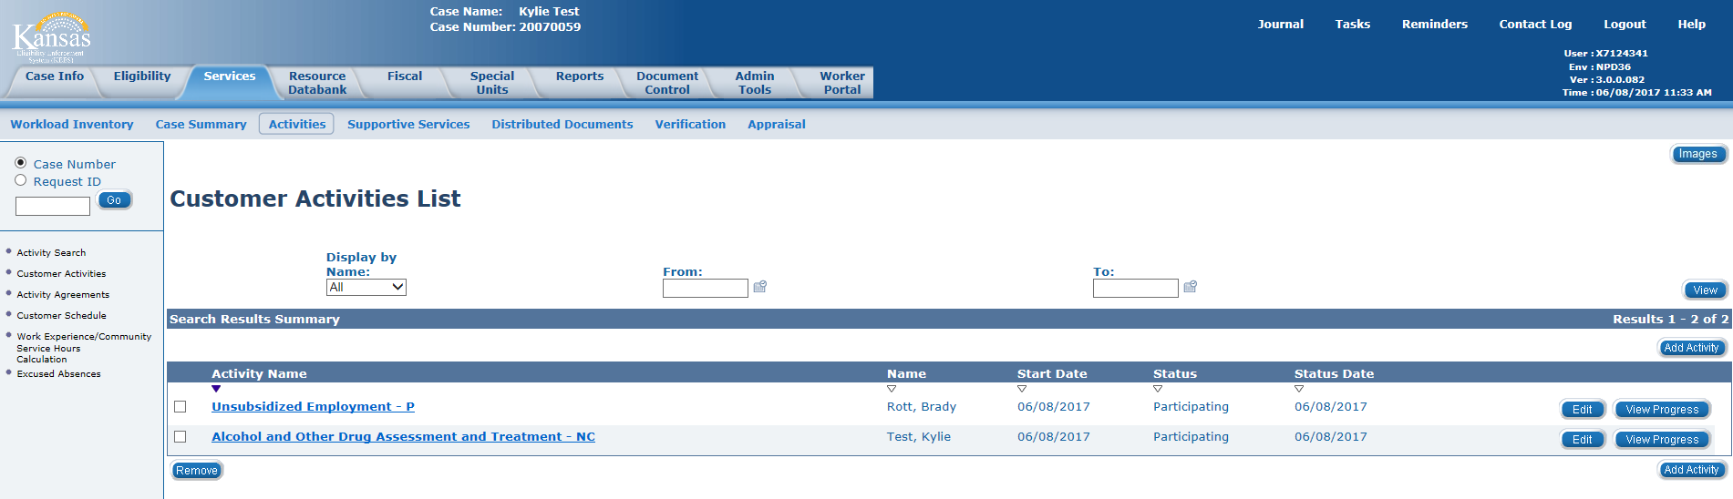

## Activity Progress Detail page

This page is where the actual hours of participation will be entered. If there are 0 hours to report for the activity, there is no need to go to this page. The career navigator will need to select the View Progress button on the Customer Activities List page for each activity with participation hours. Once the Activity Progress Detail page is open, the career navigator will select the Edit button and enter the sample month under ‘Activity Progress History’ to enter the hours.

The report will use the ‘Average Hours Per Week’ box when determining if a case meets participation. If there are no hours entered in this box, it will look at the ‘Total Hours/Month’ Box. The report will divide the Total Hours/Month by the number of days in the sample month and then multiply by 7 to calculate the weekly hours. If there are no hours entered in either of these boxes, the report will add all the hours listed for each day in the month to get a monthly total and then calculate the weekly hours from that.

Hours should be entered in the ‘Average Hours Per Week’ box when an Employment Verification form is being used to verify the hours worked each week if the client was employed for the full month. It should also be used when the Income Amount Detail page is being used as verification of hours.

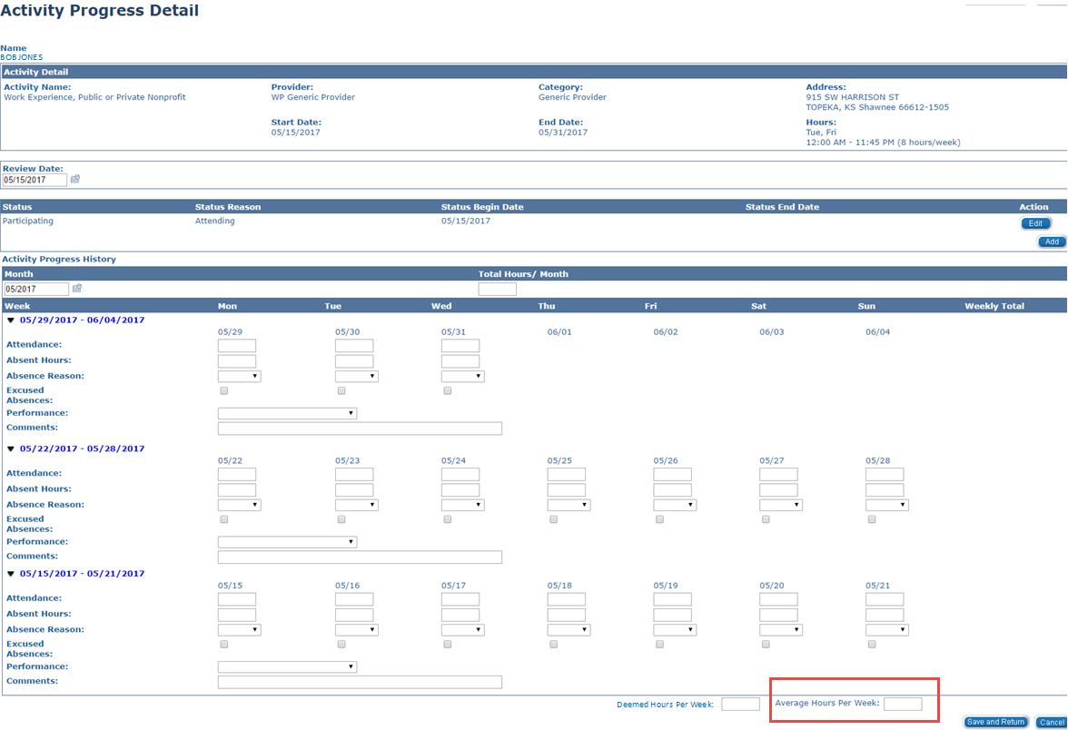

If hours are not entered in the ‘Average Hours Per Week’ box, hours can be entered in the ‘Total Hours/Month’ box. This could be used when the career navigator uses a report listing the hours for the month without a breakdown of daily or weekly hours.

The Total Hours/Month box should be used when reporting:

1. hours of self-employment.
2. hours for an activity that starts/stops mid-month.

Example: client starts job on the 5th of the month

the semester ends on the 12th of the month

1. hours for Job Search/Job Readiness (Since this activity can only be used for 4 consecutive weeks, it is ALWAYS a partial month)

**If hours were entered from the Provider Portal, the career navigator will delete all Job Search/Job Readiness hours unless the hours are being used to meet participation.**

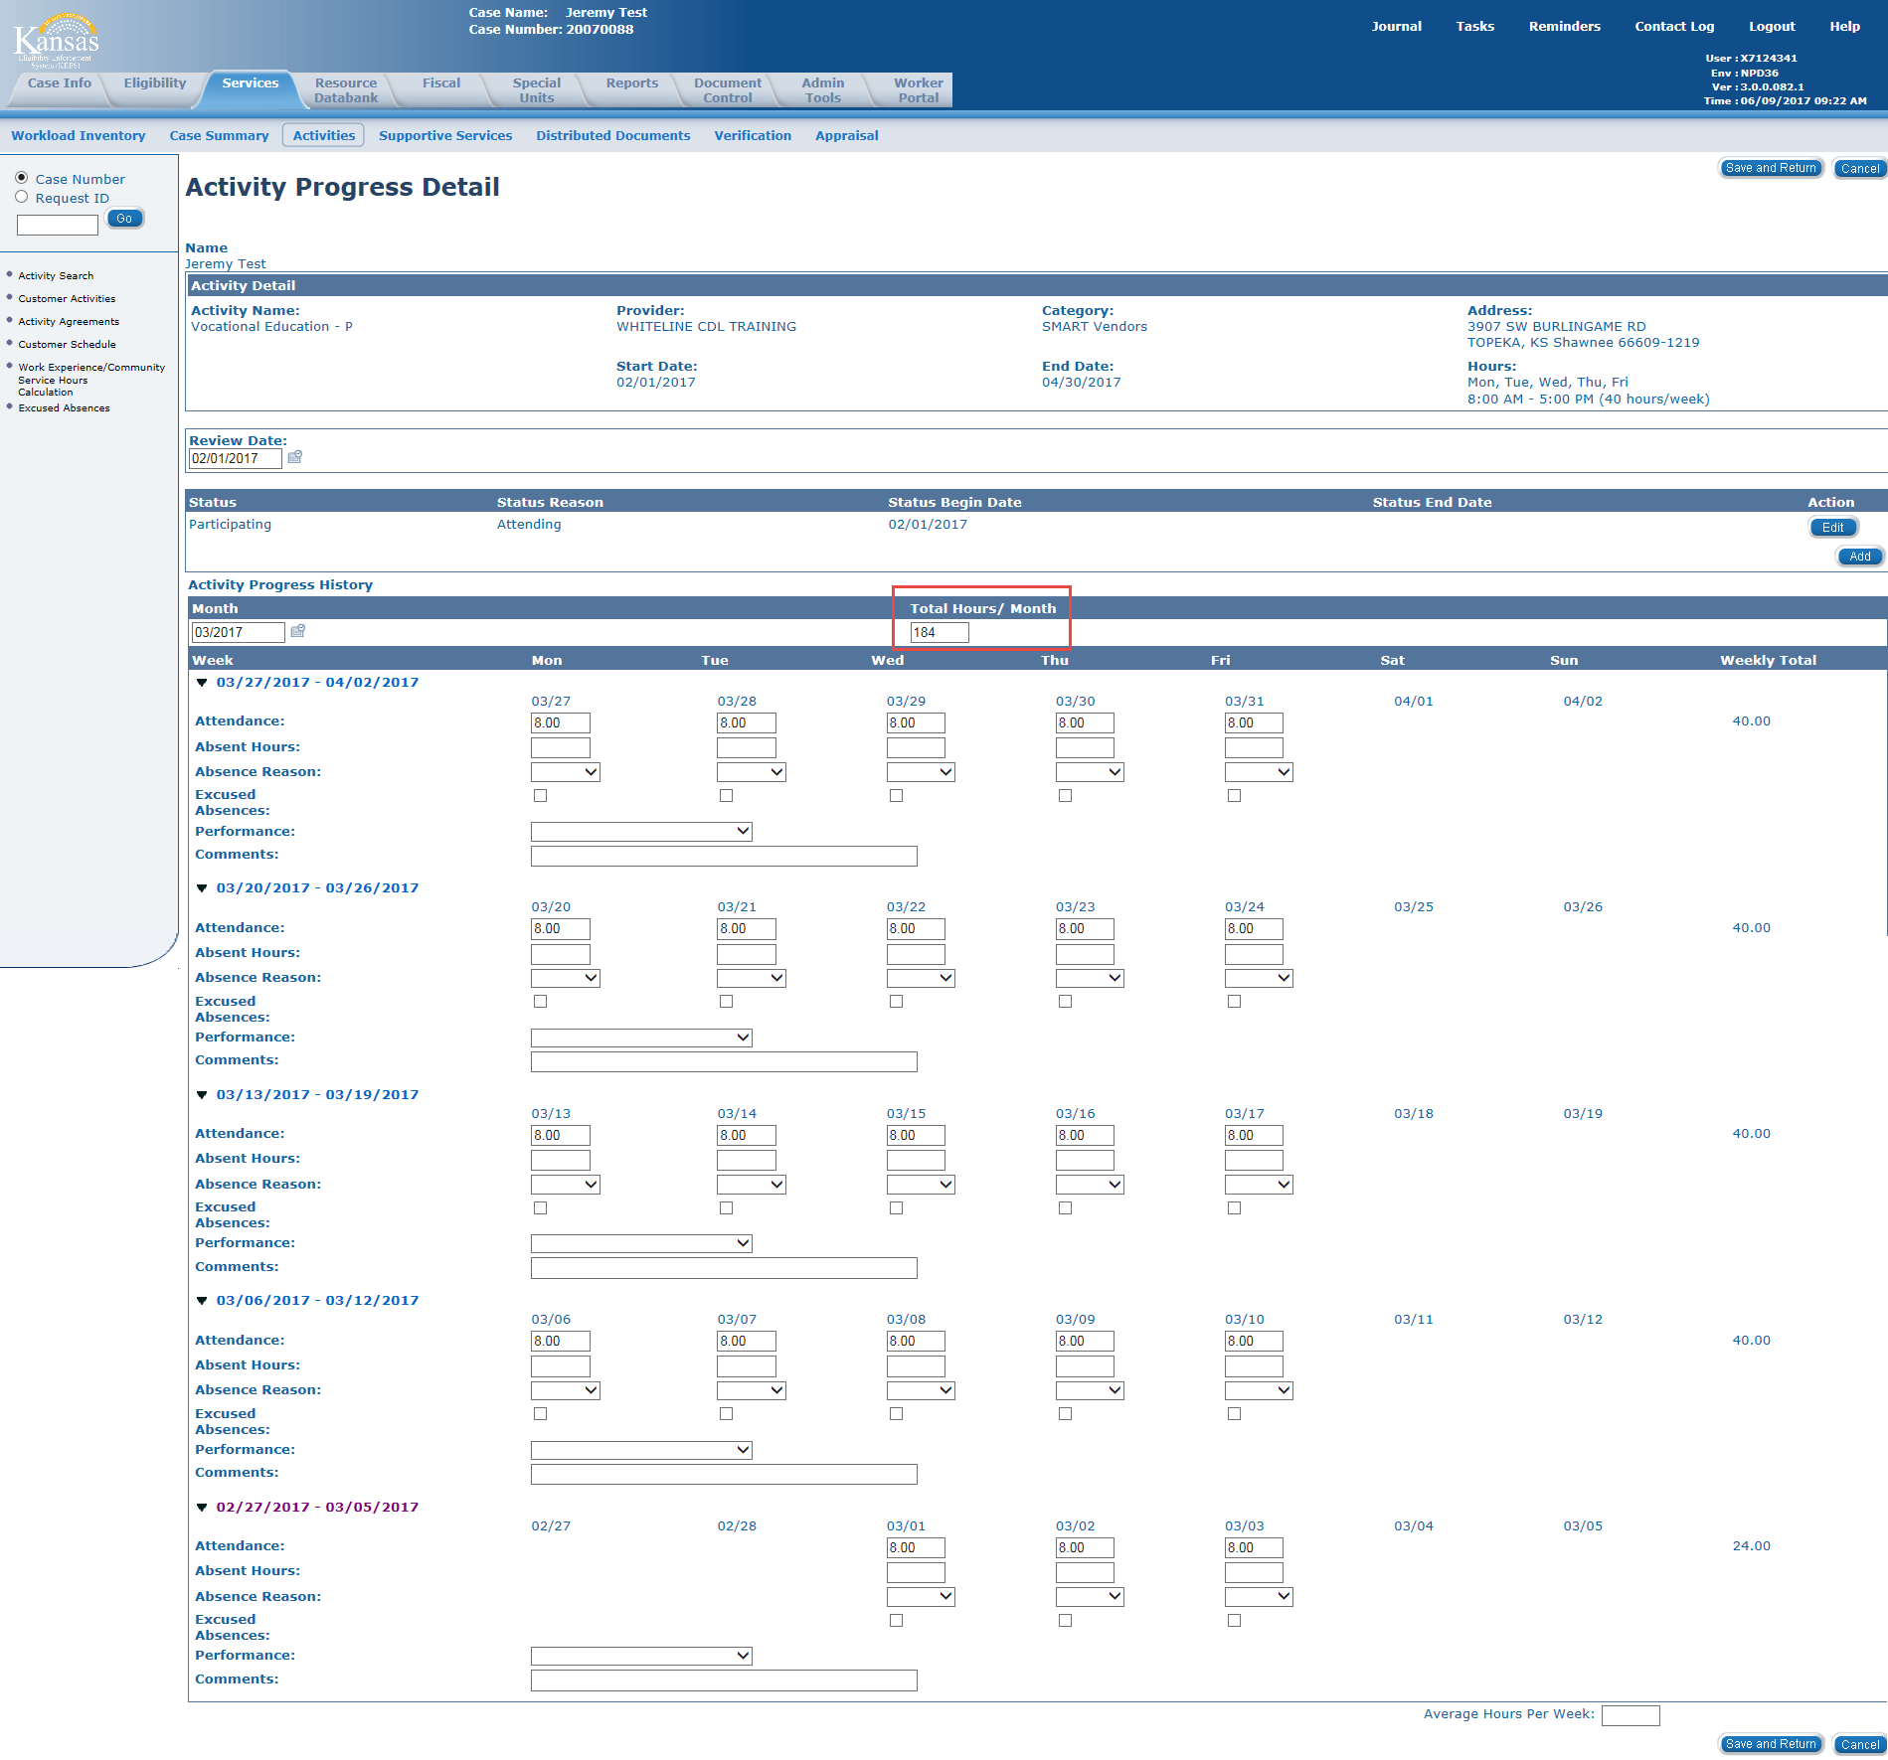

If hours are not entered in the ‘Average Hours Per Week’ box or ‘Total Hours/Month’ box, hours can be entered under each day the activity is open for the month. Daily hours will be used when hours are entered by the provider through the provider portal.

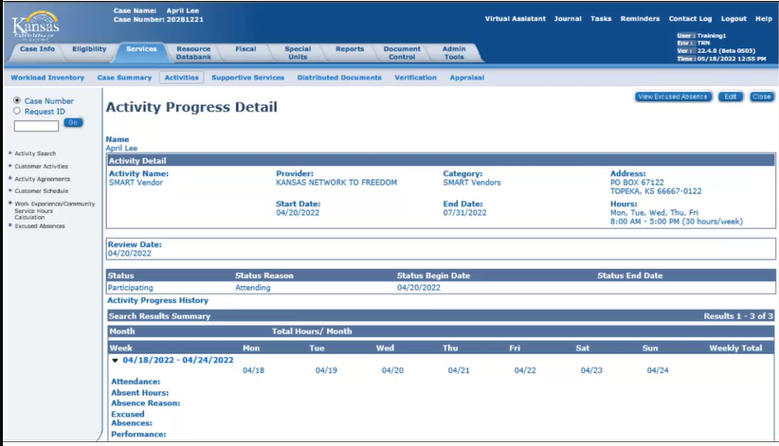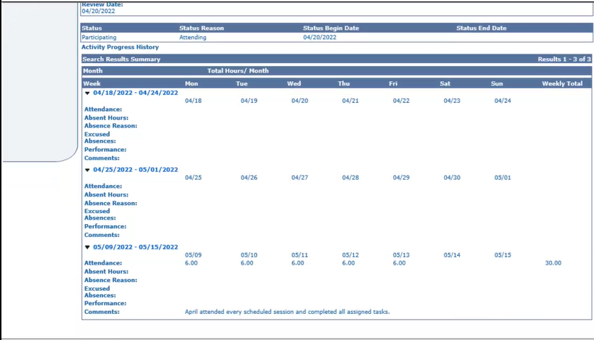

# What to include on the Checklist

## *How the Actual, Projection and Average hours are calculated*

Verification that supports the hours reported on the Activity Progress Detail page must be attached to the ES-4304. These are the hours listed on the ES-4304.

The Income List page will show the Program Type and the Program as ‘Non-Medical’ if the income is counted against the TANF grant. If the Program Type is ‘Non-Medical’ but the Program is ‘LIEAP’ or if the Program Type is ‘Medical’, the information cannot be used for work program participation.

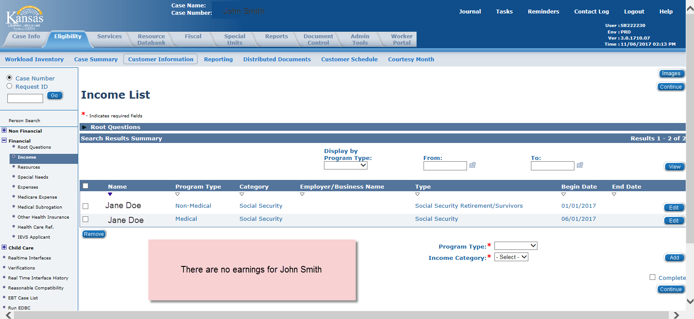

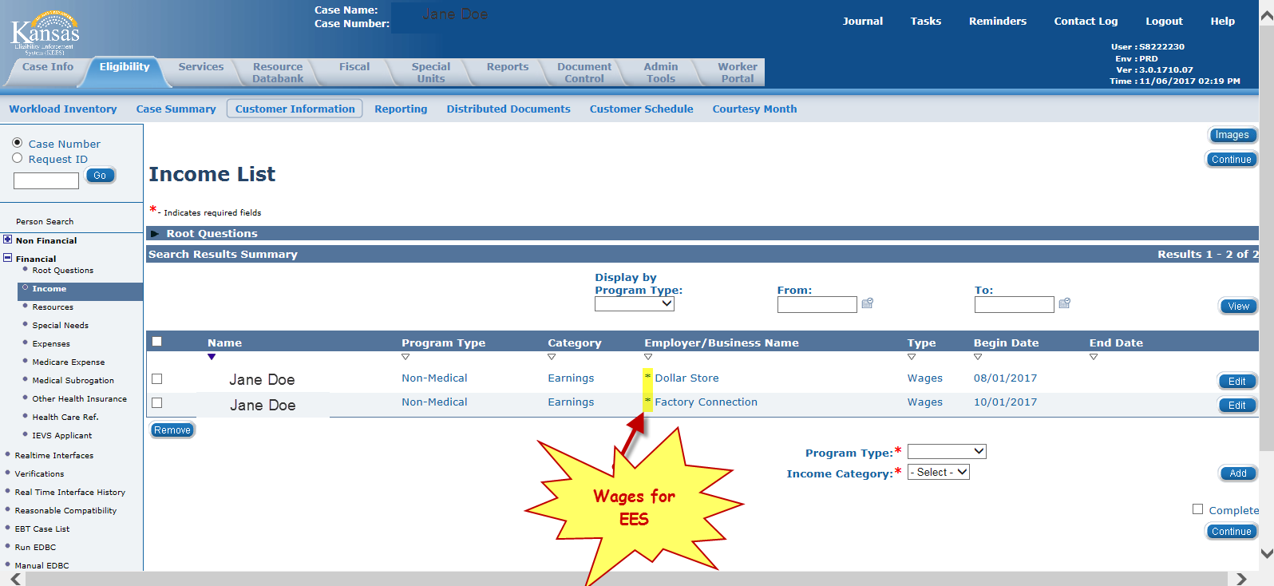

If the case has projected hours of employment on the Income Amount Detail page with a Begin Date of the sample month or before and no end date or the end date is the last day of the sample month or later and those hours are enough to meet participation, you should use that information for the sample pull. The Income Amount Detail page should be listed as the verification document on the ES-4304. No other verification of employment hours is required.

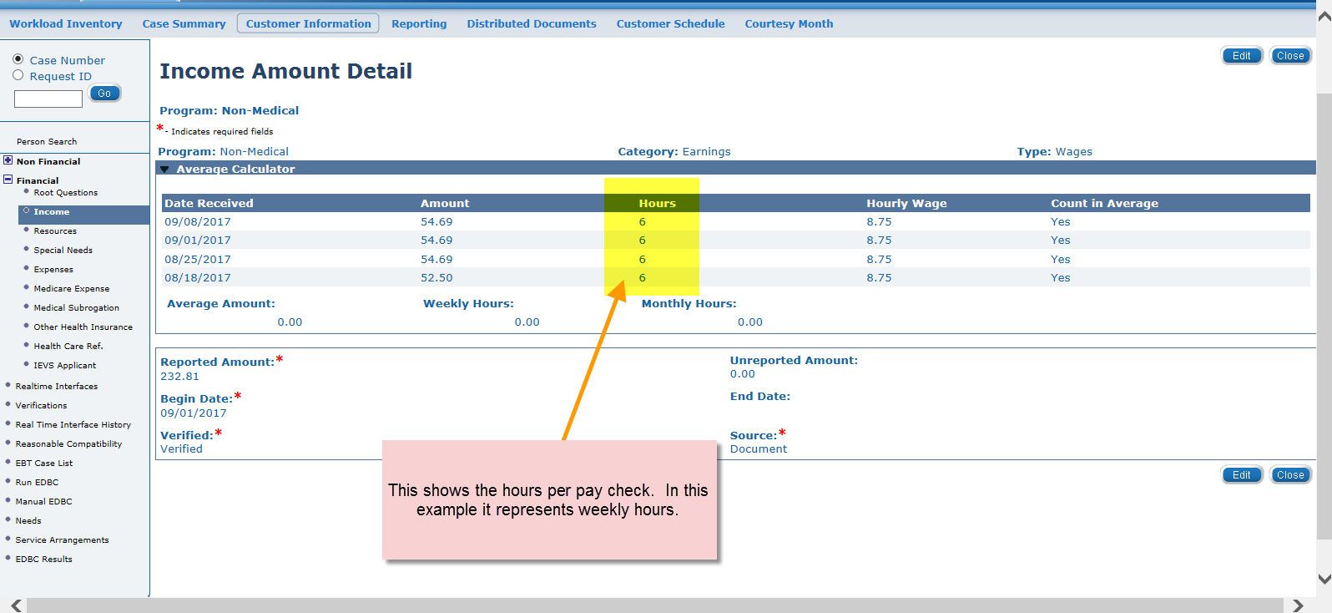

If the Hours don’t show up on the Income Amount Detail page, it cannot be used as verification even though the wages are listed. You will need to locate the verification used to calculate the wages and attach that verification to the ES-4304.

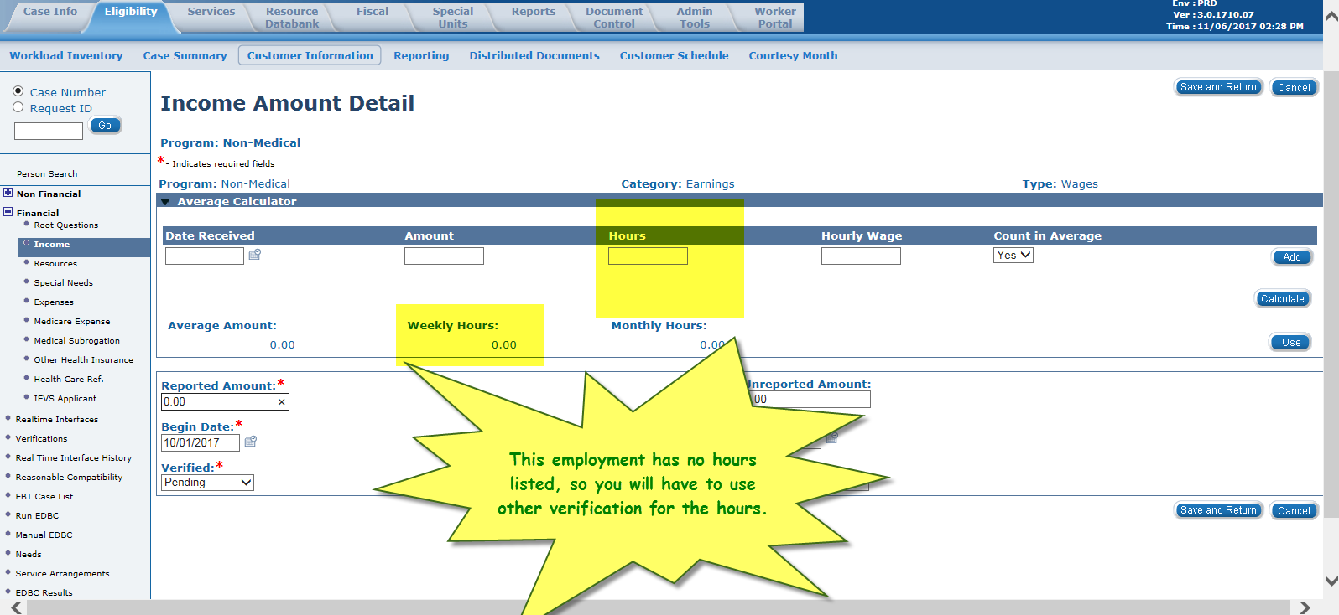

***NOTE:*** *If the client does not meet participation with what is projected, the career navigator should determine if there might be additional activities that would allow the client to meet participation.*

## *Other verifications used to calculate reported hours*

Copies of all employer’s letters, work program service providers’ reports, check stubs, work number printouts (only if they support the hours you are posting) and school schedules should be attached to the ES-4304 as verification if appropriate.

Screen print outs of The Work Number pages that do not address the month of the sample pull are not appropriate documentation and should not be included with the samples. Copies of BASI/BARI, journal entries, medical statements, Employer Contact Records, referral forms, and work sheets should not be included in the documentation. Career navigators should never voice personal opinions about or frustrations with the client on the check list. The check list will be returned to be corrected if this is found.

## *Who verified the hours if a collateral contact was made*

Remember to include their name, title, and phone number on the ES-4304.

## *Academic statement providing standard for study hours and hours in class*

If reporting supervised study hours, please provide a sign in sheet or other documentation and include the supervisor’s name and contact number. Please remember that the number of unsupervised study hours cannot exceed the amount of time spent in class or the institutions standards. Kansas will allow 1 unsupervised study hour for each hour spent in class or for each credit earned, whichever is least, unless other documentation is provided. If the institution does not assign credit hours for a class, we would use the amount of time spent in class.

# Primary Activities

**All eight primary activities meet the federal definition of primary activities**.

If a client is involved in an activity but you are not sure it falls into one of these eight categories, please contact the ES Program Administrator or the TANF Program Specialist before counting the hours on the Activity Progress Detail page.

## *1. Unsubsidized Employment*

Activities include full time/part-time employment, self-employment (see KEESM 6313), and/or Job Corps

## *2. Subsidized Public Employment*

This activity is to be used when an employer or intermediary receives a government grant to cover the participant’s salary in the public sector. The intermediary monitors the participant and the employer. It also includes Federal Work Study and other government supported employment.

## *3. Subsidized Private Employment*

This activity is to be used when an intermediary (i.e., temporary staffing agency or contracted employment service provider) receives a fee to cover the participant’s salary in the private sector. It also includes Non-Federal Work Study and other supported employment such as a recovery coach. A recovery coach is a community-based barrier remover who attempts to engage, and help addicts or alcoholics stay connected and supported within the recovering community.

## *4. Work Experience*

Activities are as follows:

* An unpaid work experience assignment through the Workforce Center that allows the client to develop a current work history, establish a work reference, improve work habits, and increase the client’s self-esteem and self-confidence,
* An unpaid Internship/Practicum/Clinical assignment to fulfill an academic requirement,
* Peer Support Mentor I & II/Coach within a treatment center/substance abuse service setting defined as co-facilitation of group sessions, development, and delivery of educational lectures,
* Tutoring of other treatment participants in preparing assignments, and reading required assignments to treatment participants with poor reading skills, and/or
* Informal, short-term activities that prepare the client to be placed at a work experience site through the Workforce Center and are included in the work experience program criteria.

## *5. On-the-Job Training*

Activities include:

* Public or private sector employment that provides significant training in knowledge and skills essential to job performance of subsidized or unsubsidized employees while they are engaged in productive work. This training would be additional to what is generally provided to new employees.
* Supported employment when it includes significant on-site training in the skills and knowledge essential to job performance.
* Apprenticeship.
* A paid internship/practicum/clinical assignment to fulfill an academic requirement.

## *6. Vocational Education*

Activities include work toward an Associate Degree, work toward a Vocational Technical certificate, and work towards the completion of a Baccalaureate degree and/or post-secondary plans approved by Vocational Rehabilitation Services. This includes both classroom participation and on-line class participation.

## *7. Job Search/Job Readiness*

Job Search activities include individual or group job search and job retention services.

Job Readiness activities include community or agency workshops, support groups designated to enhance life skills, job seeking and job retention skills, substance abuse treatment, mental health treatment, rehabilitation activities including vocationally directed doctor’s appointments, physical therapy, and/or job readiness case management services.

## What WP activity to use when a client becomes enrolled in an ESL class:

All hours a client participates in English as a Second Language should be listed under the Education Directly Related to Employment activity.

## What WP activity to use when a client becomes enlisted in the military:

A client enlists in the military in October but doesn’t go to basic training until January and is

not in an activity at this time. The case is pulled for a November sample.

Question 1: Would client be placed into Unsubsidized Employment when he goes to basic?

Answer 1: Assuming this is a 2P HH, we first need to determine how long will the client be out of the home?  If he is going to be out of the home for 180 days or less, he can stay on the case and all his income is countable.  Will eligibility keep him on the case or remove him?  If eligibility keeps him active on the TANF case, he would be considered employed full time and the correct activity would be Unsubsidized Employment once he leaves for basic.  If/when eligibility removes him from the TANF case, his WP block would be discontinued and there would be no activity open for him.

Question 2: Can we place the client in the Job Search/Job Readiness activity to capture his preparation until he leaves for basic training?

Answer 2: If this is a 2P HH, he could be placed in the Job Search/Job Readiness activity while he prepares to leave for basic, but the hours must be verifiable hours of participation and will probably be minimal. Therefore, the other parent would need to make up the additional hours to meet the participation requirement of 35 hrs/wk (if no CC).  Otherwise, he could be put in the Two-Parent Parent Responsible for Child Care activity while the other parent meets the full 35 hrs/wk (if no CC).

# Calculating Hours for Employment

The career navigator should use the greater number of hours for participation from either the projected calculations or actual hours. The career navigator may need to explore several options to determine which method will result in the most accurate and favorable result. Projected countable hours of participation for employment are determined in the following manner:

* *Regular Earnings, Apprenticeship, Internship*

Hours of participation should be based on the most recent report of They may use an employment letter, pay stubs or documentation of the earnings during the sample month or for the past 30 days. If the gross pay is provided and the rate of pay is provided but not the hours of employment, the total earnings may be divided by the rate of pay to determine the hours worked. Pay stubs will usually provide the number of hours worked for each pay period. When using pay stubs, the career navigator may average the most recent consecutive pay stubs, or they may calculate the actual hours worked in the sample month. The order of preference for verifications used is:

1. Income Amount Detail page
2. Check Stubs
3. An Employment Letter
4. E-mail or Written Statement from the Employer/School
5. The Work Number
6. Collateral Contact with the Employer

***NOTE:*** *The weekly hours of participation will be projected forward for 6 months from when the individual initially becomes employed and recalculated at the six-month work program progress review or upon client report of change. If the client’s case is pulled for another sample during that six-month period, career navigators* *may report the same projected hours.*

## *Calculating Hours of Employment in a Full Month*

If the Income Amount Detail page shows Weekly Hours for the sample month and those hours are enough to meet participation, enter the Weekly Hours in the Average Hours per Week box on the Activity Progress Detail page. No calculations are required.

If there are no Weekly Hours showing on the Income Amount Detail page or the total hours from all the activities do not meet participation, further investigation is required. The career navigator should check the case file for verification of employment hours. If we have an employment letter that was completed prior to the sample month and there has been no reported change in hours, the employment letter can be used to verify the hours of participation. If the case still does not meet participation, the career navigator should check BASI, and the Work Number for unreported employment hours.

If the employment can be found on the Work Number and it shows the average weekly hours (located under Income and Deductions for The Work Number) for an active employer and those hours meet participation, enter the weekly hours in the Average Hours per Week box on the Activity Progress Detail page.  If the employment is on the Work Number but there is no average weekly hours listed, you will need to calculate the hours for participation using check stubs. This can be done in several ways. Here are some examples:

Example 1:

Mary is **paid weekly**. Using her most recent 30 days of check stubs, we see that she worked 35 hrs in WK1, 32 hrs in WK2, 29 hrs in WK 3, 36 hrs in WK4, and 30 hrs in WK5. A weekly average can be calculated by adding the hours and dividing by the number of checks. (35 + 32 + 29 + 36 + 30 = 162 / 5 = 32.4). The career navigator should enter 32 in the Average Hours per Week box on the Activity Progress Detail page.

Example 2:

Karen is **paid bi-weekly**. Using her most recent 30 days of check stubs, we see that she worked 63 hrs on the first check and 55 hrs on the second check. An average can be calculated by adding the hours and dividing by the number of checks. (63 + 55 = 118 / 2 = 59) This gives us the average for the pay period, so we need to divide by 2 since there are 2 weeks in each pay period. (59 / 2 = 29.5). The career navigator should enter 30 in the Average Hours per Week box on the Activity Progress Detail page.

Example 3:

Carol is **paid twice a month**. Using her most recent 30 days of check stubs, we see that she worked 48 hrs on the first check and 39 hrs on the second check. Since the 2 checks are for exactly 1 month, we can add them together to get the total hours worked in the month. (49 + 39 = 88). The career navigator should enter 88 in the Total Hours/Month box on the Activity Progress Detail page.

## *Calculating Hours of Employment in an Application Month*

1. If a sample is pulled for an application month and the client stopped working prior to the date of the application, no hours can be counted for participation.

Example:

Mike’s job ended 10/09/2017 and he received his last check on 10/19/2017. He applied for TANF on 10/13/17. Since the employment ended prior to the application date, we cannot count any hrs of participation from this employment.

1. If a sample is pulled for an application month and the client has been working all along, the start date for the Unsubsidized Employment activity should be the same as the Application Date.

Example:

Susan started a job in 09/2017 working 20 hrs/week but has not been able to keep up with her expenses so she applied for TANF on 10/13/17. She was approved and her case is pulled for a 10/17 sample. The career navigator will add the Unsubsidized Employment activity with a Start Date of 10/13/2017 to match the application date. The career navigator will enter 20 in the Average Hours per Week box on the Activity Progress Detail page. Since Susan is a single parent with a child under 6, she will meet participation.

1. If a sample is pulled for an application month and the following criteria is met, we should use the Application Date as the Start Date for the employment activity:
2. benefits are prorated after the first of the month,
3. client starts the job in the month of application,
4. client starts the job within a week of the application date, and
5. the client meets or exceeds the minimum average number of hours required for participation in each week employed.

Example 1:

Joanne applied for TANF on 10/16/17 and was approved. She started a new job on 10/23/17 working 30 hrs/wk. The career navigator will add the Unsubsidized Employment activity with a Start Date of 10/16/2017 to match the application date. The career navigator will enter 30 in the Average Hours per Week box on the Activity Progress Detail page. Joanne meets participation.

Example 2:

Mark applied for TANF on 10/16/17 and was approved. He started a new job on 10/23/17 working 15 hrs/wk. The career navigator will add the Unsubsidized Employment activity with a Start Date of 10/23/2017 because the hours don’t meet the minimum number of hours required for participation. Hours will be calculated the same way any partial month of employment is calculated. See Calculating Hours for Employment in a Partial Month.

Example 3:

Jill applied for TANF on 10/01/17 and was approved. She started a new job on 10/23/17 working 30 hrs/wk Mon- Fri. The career navigator will add the Unsubsidized Employment activity with a Start Date of 10/23/2017 because the client received assistance for the full month. Hours will be calculated the same way any partial month of employment is calculated. See Calculating Hours for Employment in a Partial Month.

Example 4:

Jim applied for TANF on 10/10/17 and was approved. He started a new job on 10/23/17 working 30 hrs/wk Mon- Fri. The career navigator will add the Unsubsidized Employment activity with a Start Date of 10/23/2017 because he did not start the job within 1 week of the Application Date. Hours will be calculated the same way any partial month of employment is calculated. See Calculating Hours for Employment in a Partial Month.

## *Calculating Hours of Employment in a Partial Month*

If the client starts employment after the first of the month, hours must be entered in the Total Hours/Month box on the Activity Progress Detail page. The career navigator will calculate the total number of hours worked in the month.

Example 1:

Bill starts working on 10/09/17. The employment letter shows he is working 35 hrs/wk on Mon-Fri. The career navigator will calculate the hours for the month by taking the average wkly hrs (35) divided by 7 (the number of days in the week) to get a daily average (5). The career navigator will then take the daily average of hrs (5) times the number of days the client was employed (23) to get the total hours worked in the month (115). This number is entered in the Total Hours/Month box on the Activity Progress Detail page.

Example 2:

John starts working on 10/09/17. He is paid weekly, and his first check was received 10/20 for the pay period ending 10/13. He provided check stubs showing he worked 30 hrs for the week ending 10/13, 40 hr for the week ending 10/20, 38 hr for the week ending 10/27, and 35 hrs for the week ending 11/03. The career navigator can calculate the average by adding the checks and dividing by the number of checks (30 + 40 + 35 + 37 = 142 / 4 = 35.5). The career navigator will calculate the hours for the month by taking average wkly hrs (35.5) divided by 7 (the number of days in the week) to get a daily average (5.07). The career navigator will then take the daily average of hrs (5.07) times the number of days the client was employed (23) to get the total hours worked in the month (116.64 which rounds to 117). This number is entered in the Total Hours/Month box on the Activity Progress Detail page.

Calculation for Total Hours/Month when using a Weekly Average is as follows:

Average Weekly Hours / 7 X Days Employed in the Month = Total Hours/Month

## *Calculating Hours for Day Labor*

**Day Labor** is work done where the worker is hired and paid one day at a time, with no promise that more work will be available in the future. Employment is usually unstable and insecure, resulting in unpredictable monthly earnings.

*Examples of Day Labor Employers:*

Labor Ready, Labor Finders, Labor Max, Apprentice

*If eligibility has established a 3-month average on the Income Amount Detail page, we can use that average for the hours of participation.

**Actual hours for the month should be used if available.**

**If actual hours for the full month are not available, you may use an average based on when the employment started.** Hours can be entered in each daily box as appropriate, or the hours can be totaled and entered in the Total Hours/Month box on the Activity Progress Detail page.

* 1. If the person just started the job in the sample month, hours can be calculated by taking the total hours worked divided by the number of days including the first check and last check counted and multiplied by the number of days in the month the client was employed.

*Example:*

A sample is pulled for May. Carl started his job on May 10th and worked 4 hours. He worked 5 hours on May 12th, and 5 hours on May 23rd. We know Carl is still working for the company, but we don’t know if he worked any hours after the 20th in May. Hours can be calculated by adding 4 + 5 + 5 = 14 hrs. The number of days including the first check and last check counted is 14. The number of days in the month that the client was employed is 22 (31 – 9 = 22). Countable hours for the month are 22 (14 /14 * 22).

* 1. If the person started the job prior to the sample month but has worked there less than 3 months, an average may be used based on the number of weeks employed.

*Example:*

A sample is pulled for April. Jane started the job on March 8th and the last check stub provided was received May 5th. She worked a total of 45 hrs during this time frame. Looking at a calendar, we can see these covers 9 weeks. Hours can be calculated by taking 45 divided by 9 to get a weekly average of 5. 5 Hours will be entered in the Average Hours per Week box on the Activity Progress Detail page.

* 1. If the person started the job prior to the sample month and has worked there at least 3 months, a 3-month average may be used.

***Document how income was calculated! Hours entered should reflect the total countable hours for the month. Ex. If a client works at $10/hr and earns $30 for 1 day and then works another day at $8/hr for 5 hours earning $40, the income entered for the month would be $70 and the hours entered for the month would be 8.***

## *Calculating Hours for Self-Employment*

Eligibility is responsible for determining the Countable Self-employment Income and entering it on the Income Detail page. This will show up on the Income List page with a Program Type of Non-Medical and a Category of Self-Employment. The career navigator will calculate the hours of participation by dividing the Self-Employment Income by Minimum Wage. The hours will then be entered in the Total Hours/Month box on the Activity Progress Detail page.

If Eligibility is counting income as Employment Income but no hours are listed on the Income Amount Detail page and the career navigator and their PA believe the employment is actually self-employment, they may request the TANF Program Specialist review the case. **If the TANF Program Specialist determines the employment meets the criteria for self-employment**, the career navigator will use the monthly income to calculate the hours of participation by dividing the Income by Minimum Wage. The hours will then be entered in the Total Hours/Month box on the Activity Progress Detail page. Eligibility will not be asked to change their determination.

Example for a Full Month:

David has $500 of Self-employment income being counted on his case for the sample month. $500 / $7.25 = 68.96 hours. The career navigator will enter 69 in the Total Hours/Month box on the Activity Progress Detail page for David’s Unsubsidized Employment activity. A copy of the **Income Detail page** will be attached to the sample form for verification.

If this is a new job (less than 3 months), a prospective estimate can be used based on the client’s statement until an average is established.

If a sample is pulled for an application month and the client has self-employment, the total number of hours for the month will need to be divided by the number of days in the month and multiplied by the number of days on assistance.

Example for an Application Month:

Robert applied for TANF on 10/23/17 and was approved with $500 of self-employment income being counted on his case for the month. The total number of hours for the month came to 69. 69 hours / 31 days in October X 9 days on assistance = 20.03. 20 should be entered in the Total Hours/Month box on the Activity Progress Detail page for Robert’s Unsubsidized Employment activity.

## *Calculating Hours for Work Experience*

The current benefit amounts are used to determine the number of assigned hours. When a client is participating in the Work Experience activity through the Workforce Center, the Comm. Service Hours Calculation Detail page must be completed. The career navigator will enter the Total Hours of Participation Required per week for the client, then click on the ‘Calculate’ button. The system will calculate the number of hours required for the activity and give you the Maximum Average Unpaid Work Experience/Community Service Hours per Week. A copy of the Comm. Service Hours Calculation Detail page must be copied into Perceptive Content. It will be used to document hours of participation for the Work Experience activity.

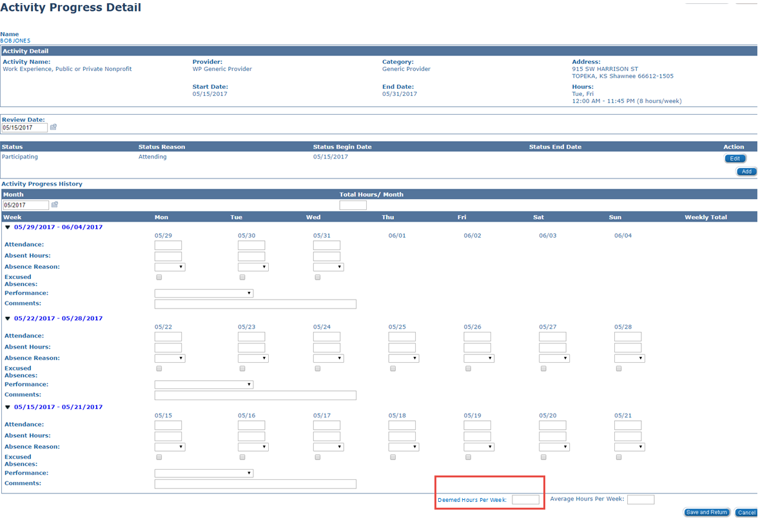

Example: According to the Comm. Service Hours Calculation Detail page, the client is required to participate for 13 hours per week to meet participation.

## *Calculating Hours for Vocational Education*

A statement from the training institution that defines hours of study needed to assure progress towards successful completion of the course can be used to determine study hours. Verification of the credit hours the client earns for the class can be used in place of a written statement. If no statement is available, Kansas will allow 1 unsupervised study hour for each hour the client spends in class. The number of unsupervised study hours cannot exceed the amount of time spent in class or the institutions standards.

Example: John has provided a copy of his class schedule from the local community college. His case was selected for the WP Sample for April. Since we only need to report activities for the sample month, the career navigator would enter the hours for class time, supervised study time, and unsupervised study time from the schedule on the Activity Progress Detail page as shown below.

Student Schedule for: John Client

Spring 2017 Semester Course Schedule___________________________

Start End Credit

Course Title Days Time Time Start Date End Date Hours

101 Gen Biology M W F 11:30AM 12:20PM 01/13/2017 05/10/2017 4

102 Biology Lab W 02:00PM 03:50PM 01/18/2017 05/03/2017 0

103 Speech T R 09:30AM 10:50AM 01/12/2017 05/09/2017 3

104 Eng Comp I M W F 12:30PM 01:20PM 01/13/2017 05/10/2017 3

105 Gen Psych M W F 10:00AM 10:50AM 01/13/2017 05/10/2017 3

Total Credit Hours: 13

The schedule shows that John is in class for a total of 14 hours each week and he will earn 13 credit hours. Therefore, John has a total of 27 Vocational hours that will count for participation.

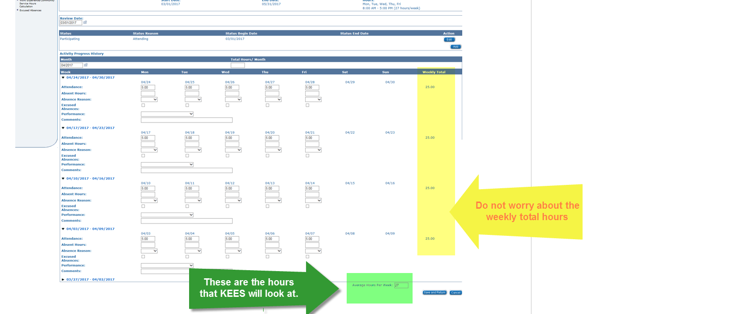

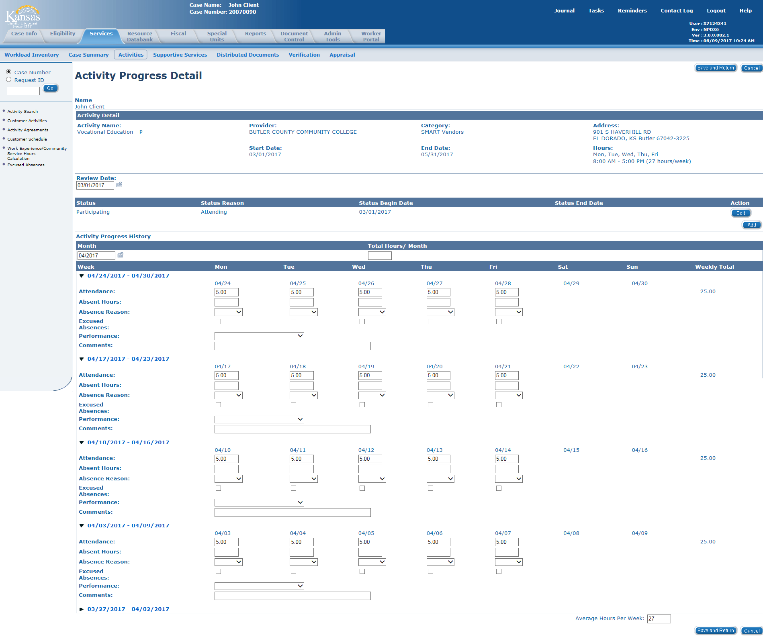

## *Calculating Hours for Job Search/Job Readiness*

Only actual hours of participation may be counted. The limits of 4 consecutive weeks and 6 total weeks for the Job Search/Job Readiness will apply to the current month and the prior 11 months for that client. The system will not restrict the number of weeks that Job Search/Job Readiness can be used so the career navigator will be responsible for reviewing the case history and monitoring the number of weeks used. Hours can be entered Daily for the 4 consecutive weeks or the 4 weeks can be totaled and entered in the Total Hours/Month box. Hours should not be entered in the Average Hours per Week box as this activity is ALWAYS counted as a partial month.

**Job Readiness**

Activities attendance documentation is provided by the job readiness supervisor. If the hours on the ES 4304 were verified by a contracted provider, the verification listed on the checklist would be ‘e-mail’, ‘data base’, ‘collateral call’, or whatever source the worker is using. If the hours on the ES 4304 were verified by the career navigator, the verification listed on the checklist would be ‘collateral contact’, ‘attendance record’, ‘Job Readiness Activities form’, or whatever source the career navigator is using. All hours must be verified to be countable.

**Job Search**

Hours will be listed on the Job Search Activities form. The Job Search Activities form should be Imaged into the electronic file but should not be attached to the Checklist (ES 4304) as verification. If the hours for the Job Search Activity were verified by a contracted provider, the verification listed on the checklist would be ‘e-mail’, ‘data base’, ‘collateral call’, or whatever source the career navigator is using. If the hours on the Job Search Activities form were verified by the career navigator, the verification listed on the checklist would be ‘collateral contact’ and the contact information should state ‘Job Search Activities form in file’.

If the client is doing Individual Job Search, the time is to be recorded by the client on the Job Search Activities form and turned into the career navigator weekly. Reasonable client reports will be accepted along with the verification of at least 10% of the contacts reported. All online and fax applications must be documented with application or transmission confirmations.

Example: Susie applied for TANF in January. She has a child under 6 yrs. so she needs a minimum of 20 hours each week to meet the federal participation requirements. She was assigned to Job Search/Job Readiness in February and her case was selected as a Sample for March. Since we only need to report activities for the sample month, the career navigator would enter hours for the 4 consecutive weeks in March on the Activity Progress Detail page.

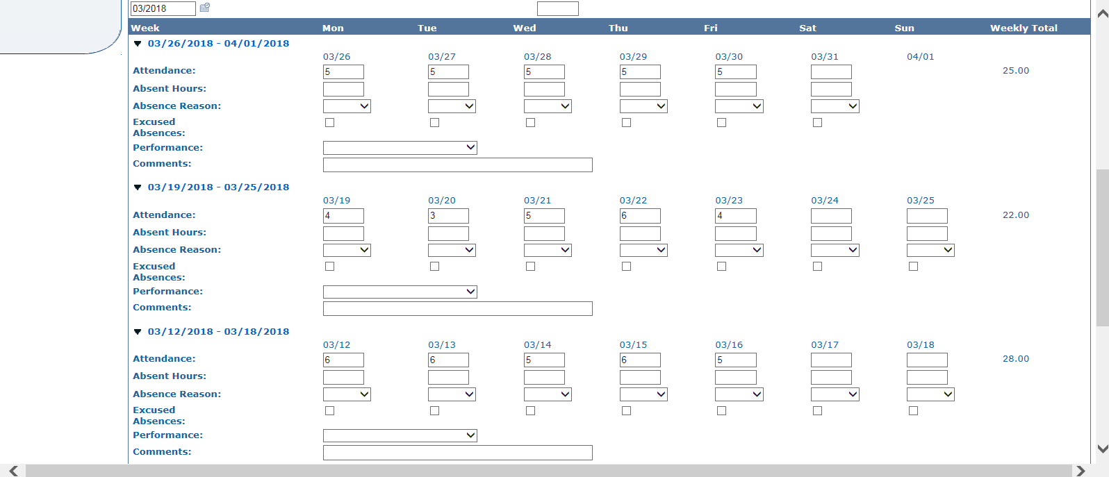

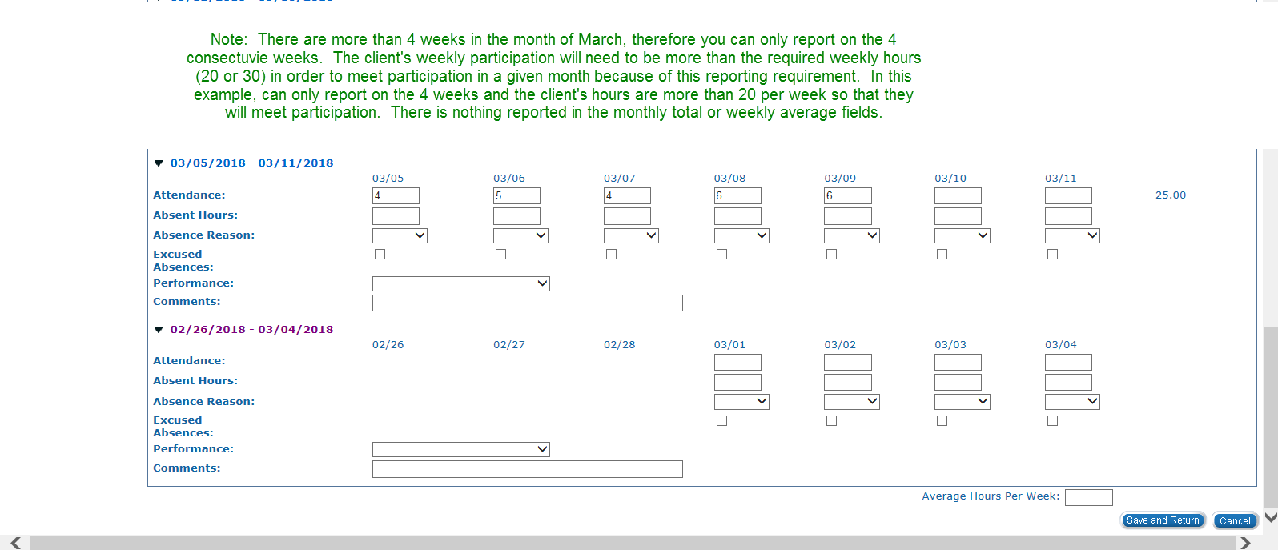

If Susie had been pulled for the sample in the previous eleven months and she had been reported in Job Search/Job Readiness for four consecutive weeks, the career navigator should only post two weeks of Job Search/Job Readiness and the client would not meet participation with Job Search/Job Readiness alone.

# Secondary Activities

**All secondary activities meet the federal definition of work activities.**

## *1. Job Skills Training*

Activities include literacy instruction, customized training, and/or language instruction focused on skills for employment. An example of customized training is an employer mandated customer service training.

## *2. Education Directly Related to Employment*

Activities are adult basic education (ABE) and/or other courses designed to provide knowledge and skills for specific occupations or work settings. This activity is **NOT** appropriate for clients with a high school diploma or GED unless it is an ESL class. This activity is to be used for **all** English as a Second Language (ESL) classes.

## *3. Satisfactory Attendance at Secondary School or in a GED Program*

High school and GED count as activities.

*Teen parents attending high school or working towards their GED will meet participation if the teen is satisfactorily participating in high school or a GED program*. *The hours for satisfactory attendance in a GED program is the equivalent of the* *hours offered by the local GED program unless the client has other limiting factors that hinder participation.*

***NOTE:*** *Hours for Education Directly Related to Employment and Satisfactory Attendance at Secondary School or in a GED Program are primary work activities for teen parents. A teen parent is defined as a parent under the age of 20 who does not have a high school diploma or GED.*

Remember, GED or high school is considered a secondary activity for a client 20 and older. If the studies are incorporated into a vocational training program as part of the curriculum needed to complete the course, those hours would count as primary Vocational Education hours.

# Parents Not in Work Programs

Parents who are not active in the Work Programs block may be eligible to be counted toward meeting the federal work participation requirements. This could include parents receiving TANF but exempt from work programs with an exclusion reason of One Parent HH or Caring for Disabled HH Member on the Work Registration List page. It could also include parents with the role of UP or FRE in the TANF block on the Case Summary page. For the hours to be counted in the system, additional steps must be taken. The following steps should only be taken if the parent will meet participation:

1. To count these parents for work participation, staff must open them on the Work Program block.

2. Add the primary activity for the month starting with the first day of the sample month.

3. Enter the hours of participation on the Activity Progress Detail page.

4. After entering the hours for these parents, end the activity with the last day of the sample month and discontinue the client’s status in the Work Program block.

***Note:*** *Activities do not need to be kept open to be included for the sample month. After Hours have been entered, the client can be discontinued on the Work Program block even though the preliminary or federal reports have not been created.*

# Other Tips:

* Don’t use Job Search/Job Readiness hours if participation is not met.
* If the six month’s projection for income is current and meets participation, **DO NOT** ask for actual income.
* Only volunteers should have a Status Reason of Engaged in Non-Federal Participation.
* SSI recipients can **NOT** be volunteers because they are not eligible for employment services even though we are allowed to count their hours of participation.
* The End Date on the Customer Activity Detail page must be updated when an activity has the Status of Removed or Completed added on the Activity Progress Detail page.
* Hours of participation can be counted for an ineligible alien **ONLY** if the ineligible alien is the parent of a child on the case. Hours cannot be counted for an ineligible alien when the ineligible alien is a cohabiting partner.

# Helpful Hints if Federal Participation is Not Met

• Can you use more than one activity to meet participation?

• Enter actual hours for all primary and secondary activities (except Job Search/Job Readiness) even if it doesn’t meet participation.

• Have you checked BARI, BASI and The Work Number? If there is employment information in the current quarter or the prior quarter, the career navigator should investigate to determine if the client was employed in the sample month and document the response in a Journal entry.

**BARI/BASI Instructions**

When BARI/BASI is checked, the career navigator should only look at the current quarter and 1 quarter prior. If info is found, the Journal entry should include the following:

1. The last employer’s name and quarter listed on BASI for each adult or minor parent on the case.
2. If the employment was not previously reported and BASI does not show the employment has ended, the career navigator should send an ES-4302 to the employer. Info can be found on EARA.
3. Documentation of employment termination is required for all reported employers listed in the current and last quarter on BASI if the client is no longer employed.  This documentation must include:
4. Month of termination if prior to the sample month
5. Date of termination if job ended in the sample month
6. Source of verification (employer letter/collateral contact/Work Number/BARI)
7. If no documentation for the employment termination can be found in the file and client reports they are no longer employed there, the documentation must state this and include the following:
8. date the employment termination verification was requested
9. date the info is due.
10. If client reports they are still employed but no verification of the employment is in the file, the documentation must state this and include the following:
11. date the employment verification was requested
12. date the info is due.

# Things to Remember Before Checking the Work Number:

1. check for hours of participation in all activities that were active in the sample month.
2. check the Income Amount Detail page for employment hrs.
3. All verified hours for each activity should be listed on the ES-4304.

Below is a partial list showing the most common Verifications that can be used to verify hours of participation for employment. They are listed in order of preferred use. This means if we have hours on the Income Amount Detail page that enable the client to meet participation, the Income Amount Detail page should be used, and no further investigation of hours is required. If the hours do not meet participation on the Income Amount Detail page, we should look for the most current verification in the file. If we have current check stubs showing hours that enable the client to meet, the check stubs should be used as verification and no further investigation of hours is required. If hours still don’t meet participation and the check stubs are not current but we have an Employment letter that shows hours that meet participation, we should use the Employment letter as the verification of hrs.

1. Income Amount Detail page
2. Check Stubs
3. An Employment Letter
4. E-mail or Written Statement from the Employer/School/Provider
5. The Work Number
6. Collateral Contact with Employer/School/Provider (if collateral contact is already documented in a Journal entry for the activity, there is no reason to call again)

(If you use a collateral contact as verification of the hours, you must list the name of the person, their title or company name, and the phone number that you called for the information on the ES-4304)

If the client does **NOT** meet participation with hours listed on the ES-4304, **THEN** you will need to investigate further by checking the Work Number. If there is a copy of the Work Number in ImageNow that was run after the sample month, use it. **DO NOT** request a new Work Number.

The reason we check the Work Number and BASI is because we are looking for employment hours to meet participation. If the client is already meeting participation, we don’t need to look for other hours.

**Checking the Work Number:**

If the case does NOT meet participation and the Work Number is checked, it should be checked for each client on the Sample list.

If there is a copy of Equifax/Work Number in the file that was checked after the sample month, there is no need to recheck Equifax. If the copy of Equifax/Work Number is from the sample month or prior, a new check in Equifax/Work Number will be required.

If a case is pulled two months in a row for a sample, a new Equifax/Work Number will be required for the second month. Steps to follow after signing on to the Work Number:

1. Enter the client’s SSN.
2. Select EES Employment Services as the Benefit Program.
3. Select 3 Full Months as the Pay Range.
4. Select SS Verification as the Verification Type.
5. Click on the Start Order button.
6. The Employer should be selected for an Income Report if a case is pulled for a December sample and the Work Number shows an Employer as “Active” and the Last Pay Period is in October, November, December, or later. If the Last Pay Period is prior to October, the Employer should not be selected.
7. Print all pages of the Print Order Details into Perceptive Content if the hours are used for the sample.

# Minimum Hours of Participation to meet the Federal Participation Rate

Remember, not everyone needs 30 hours per week to meet participation.

* A minimum of 20 primary hours is needed for single parents with children under the age of six.
* A minimum of 30 hours is the rule for single parents with children aged six and older. Of the 30 hours, 20 must be in primary activities.
* A minimum of 30 hours is needed for two-adult households if no DCF childcare is being used. These are the families that don’t have mutual children. Of the 30 hours, 20 must be in primary activities. If there is a child under the age of 6, at least 20 of the hours must be in primary activities and all 20 must be completed by one adult. If there is not a child under the age of 6, all 30 hours must be completed by one adult.
* A minimum of 35 hours is needed for two-parent families when DCF does not pay childcare. Of the 35 hours, 30 must be in primary activities.
* A minimum of 55 hours is the rule for two-parent households, when DCF childcare is used. Of the 55 hours, 50 hours must be in primary activities.
* Teen parents who attend high school or GED classes will meet participation if they are satisfactorily participating in high school or a GED program. The hours for satisfactory attendance in a GED program are the equivalent of the hours offered by the local GED program unless the client has other limiting factors that hinder participation.

# Q&A

**Q:** When a client reports that they are sick for several days, or that they had to stay home with sick children, does staff have to get Doctors statements to document good cause? Many times, the client does not go to the doctor for minor illness or colds.

**A.** If a client reports in a timely manner that they are sick or that they have sick children and cannot attend an activity, the career navigator can act as the “other source” for documenting an excused absence. The career navigator may note the client’s report in the file logs and use that as documentation. The career navigator will use their best judgment and knowledge of the client to decide which reports will require a doctor’s statement for documentation.

**Q.** Can I count the time it takes a client to complete the Self-Assessment, the SASSI and our local orientation towards participation?

**A.** No. If the client is only involved in the initial assessment and orientation the hours would not count toward federal participation. The 0-hour activities are just that; no hours posted for these activities will not count towards participation. If a client is in a 0-hour activity that has them participating in steps to improve their life skills or employability (financial planning classes, therapy sessions, etc.…), the CN should open a countable activity that encompasses the step and count the documented hours towards participation.

**Q:** The client completed a review two months before she was selected for the sample pull. At that time, she reported P/T employment, and we projected her hours and wages for six months. Can we use that projection for the sample pull or do we have to get new information for the sample month?

**A:** You may use the projected hours and include a copy of the materials used to produce the projection as documentation.

**Q:** I have a parenting teen who attends high school completion courses 3 hours a week. Can I deem her hours?

**A:** Hours cannot be **deemed** for the Satisfactory Attendance at Secondary School or in a GED Program activity. Teen parents who attend high school or GED classes will meet participation if they are satisfactorily participating in high school or a GED program. The hours for satisfactory attendance in a GED program are the equivalent of the hours offered by the local GED program unless the client has other limiting factors that hinder participation.

**Q:** If a case is pulled for a sample but they don’t have any countable hours, do I enter 0 hours on the Activity Progress Detail page? If so, where do I enter the 0?

**A:** If the client has no hours that can be counted towards participation in the activity, the Activity Progress Detail page should be left blank. This includes all 0-hour activities and all primary/secondary activities with no hours to count.

**Q:** Do I need to change the WP Status to Exempt for a client when a baby is born?

**A:** No. The federal report will identify if the client is eligible for the CU exemption based on KEES rules.

**Q:** What Start Date should be used on the Customer Activity Detail page when adding an activity?

**A:** Usually, the Start Date should be the date the client starts the activity. An exception to this rule is in the month of application. An activity should never start prior to the date a client is eligible for TANF.

**Q:** What End Date should be used on the Customer Activity Detail page when adding an activity?

**A:** Usually, the End Date should be the last day the client participated in the activity. However, if this is a new activity opened for the sample month only, the End Date should be the last day of the month the activity is reviewed. All activities should be reviewed at least every 6 months unless the activity is set up for Transitional services, then it should be for 12 months. Keep in mind some activities should be reviewed more often than 6 months. If a client is in school, the activity should be reviewed when the class or semester is expected to end. Work Experience should be reviewed every 3 months.

**Q:** Why should a client’s Status be Transitional instead of Sanction on the WP Status Detail page when applying a WP penalty?

**A:** Transitional must be used as the Status so that KEES will automatically close the WP block at the end of 12 months if the client doesn’t reapply.

**Q:** What is the difference between Engaged in Federal Participation and Engaged in Non-Federal Participation for an Active WP client?

**A:** All Mandatory WP clients should be Engaged in Federal Participation. Clients that are Exempt and volunteer to participate in WP should be Engaged in Non-Federal Participation.

**Q:** How far back should I check for employment found on BASI?

**A:** Current quarter and 1 quarter prior. If you are checking BASI on 12/05/17, the current quarter is 4-2017 (October, November, and December) and the prior quarter is 3-2017 (July, August, and September).